

BACHELOR OF INFORMATION TECHNOLOGY (HONS)

BIT304
Final Year Project I

PROJECT PLAN

MANTRA: Automated Penetration Testing for Web Application Using Flask Python Web Framework

PROJECT PERIOD: 28th September 2018 – 28th December 2018

Student Name: Ida Bagus Budanthara Student Id: E1500366
Student Name: I Wayan Denny Harry Caka Student Id: E1500365
Student Name: Dewa Ayu Dewanti Satya Utami Student Id: E1500355

15 Jalan Sri Semantan 1, Off Jalan Semantan, Bukit Damansara, 50490 Kuala Lumpur, Malaysia.
Tel : 603-2716 2000, Fax : 603 - 2095 7100

- PROJECT TITLE

The title of our project is MANTRA: Automated Penetration Testing for Web Application Using Flask Python Web Framework that developed using Python as a programming language and Flask as a web framework. This project built in hopes of being able to simplify the work of penetration tester when running security audit process to the website application system tested and help web developers in providing security vulnerability information contained on the developed website application without the need to understand the knowledge of information security specifically.

- PROJECT MEMBERS

No | Student ID | Name
1 | E1500366 | Ida Bagus Budanthara
2 | E1500365 | I Wayan Denny Harry Caka Pratamayasa
3 | E1500355 | Dewa Ayu Dewanti Satya Utami

- PROJECT KEY WORDS

- Website
- Hacking
- Vulnerability
- Penetration Test

- PROJECT BACKGROUND

With the development of information technology in the world nowadays, security issues in developing website applications is one of the most common problems found. Most of web developers pay little attention to the information security of the developed website application. If the security of information is not properly considered, then irresponsible people can disrupt or take authorized access to the system by exploiting the vulnerabilities of websites application. Attacks in the form of hacking can be detrimental to many parties, especially for owner of assets that successfully stolen or disseminated without authorized permission.
To prevent adverse activities caused by the vulnerability of the system, It is needed an action to overcome security issues in applications, especially in website applications that called pen test or penetration testing. Penetration testing is an activity of security testing to test the insecurity of an application. This test conducted to find the security risk that might be present in the system. The person who is doing this activity called penetration tester (Pujuarto, Utami, & Sudarmawan, 2013).
This underlies our intention to create and develop an application in the form of website that can perform penetration-testing process automatically to help penetration tester to work easier, faster, and more efficient also to help website developers to detect any vulnerabilities in the developed website application system.

- AIMS OF THE PROJECT

The main purpose of this application is to make it easier for penetration tester to perform security audit process to the tested website application system automatically and efficiently. This application also helps web developers in providing security vulnerability information contained on the developed website without the need to understand the knowledge of information security specifically. This application has the function to automatically scan and exploit the website application tested, and then it will produce a report that contains detailed information about vulnerabilities that successfully discovered and exploited by the system.
It expected that through report produced from this application could help the penetration tester to develop and expand exploitation techniques from the information obtained to find vulnerabilities that are more complex in website application. It expected that through report produced could help web developers to find out the point of vulnerability in the website application that being developed. With the information of vulnerabilities, web developers can do patching process and prevent possible vulnerabilities of the website that being developed.

- OBJECTIVES OF THE PROJECT

There are several objectives that we should set to develop an Automated Penetration Test Application, which are:
- Detecting and identifying potential security vulnerabilities contained in developed website applications automatically.
- Providing information in the form of report related to security vulnerabilities that successfully detected from the exploitation process executed from the application.
- Assessing the potential attacks and operational impact of the exploitation.
- Providing real evidence to support increased of investment in security and information technology.

- DIRECT CUSTOMERS/BENEFICIARIES OF THE PROJECT

This application intended for web developers and penetration testers. The application will provide beneficiaries to the web developers, so that they can quickly detect, overcome, and correct the vulnerabilities found in website applications that are being developed through report generated by the application. This application also provide beneficiaries to the penetration tester that they can easily perform testing process on security of a website application also can develop further exploitation techniques from the information that has been obtained to find more complex vulnerabilities.

- OUTPUTS EXPECTED FROM THE PROJECT

Details of works and tasks done by each team member:
        - Ida Bagus Budanthara
- Project background development
- Develop project objectives
- Project aims
- Literature review
- Risk management
- Prototype
        - I Wayan Denny Harry Caka Pratamayasa
- Project aims and project objectives
- Resource plan list
- Risk management
- Literature review
- Requirement gathering
- Prototype
        - Dewa Ayu Dewanti Satya Utami
- Project background development
- Project schedule development
- Literature review
- Requirement gathering
- Interface design
- Use case development
- Class and sequence diagram development
- Prototype

- ORGANISATIONS/INDUSTRIES INVOLVED IN THE PROJECT

  - STMIK STIKOM Bali
  - HELP University
  - Another application penetration testing to be used as samples in our application

- SYSTEM DEVELOPMENT METHODOLOGY
The system development methodology that we will use is Agile Methodology. This methodology usually used for developing the information systems that has ever-changing business requirements. This methodology has one of the most popular agile software development frameworks called Scrum. The Scrum simplifies process framework and focuses on teamwork. The objective of Scrum is to deliver working software and demonstrate it faster and more frequent during the software development project (Tomanek & Klima, 2015).
The major benefit of the Scrum framework is the iterative development approach and the opportunity to automate penetration tests. Therefore, the security vulnerabilities can be discovered and solved more often, which will positively contribute to the overall information system protection.
We choose Agile Methodology because it is suitable for developing application system and can easily handle continuous cycle of improvement. Therefore, that it can provide changes and improvements to the application to be as close as possible to the project scope. This methodology also focused on teamwork, so that it allows all of us as developers to communicate to each other to develop the expected website application.

RISK MANAGEMENT PLAN

No | Description | Probability % | Impact  1= low  5 = high | Mitigation Strategy
1 | Lack of skills and knowledge in developing a website application using Python as programming language and Flask as a framework. | 40 | 5 | Find online sources to learn how to develop website application using Python and Flask and do self-learning, also looking for an expert to give advice and guidance.
2 | The website application will have many bugs in development process. | 30 | 5 | Do a several unit testing and integration testing due to the process of finding bugs, also do system testing to the created prototype.
3 | The website application is not finished during project period. | 30 | 5 | Holding meeting regularly so that the project is not delayed.
4 | The UML diagram design produced is not properly to show the workflow of website application. | 20 | 3 | Looking back to previous lecture notes for creating UML diagram to refine the design and doing consultation to the project supervisor so that the correction can be given.
5 | Undetected errors due to development process. | 10 | 3 | Giving error logging system to the developed website application.

- WORK ITEMS LIST

Name / Description | Priority | Assigned To |  | Effort estimated (days)
Initiating
Meeting with Supervisor | High | Dewanti, Denny, Budanthara |  | 1
Project Theme Identification | High | Dewanti, Denny, Budanthara |  | 1
Consultation with Supervisor | High | Dewanti, Denny, Budanthara |  | 1
Project Theme Decision | High | Dewanti, Denny, Budanthara |  | 0
Planning
Project Background Development | High | Dewanti, Denny, Budanthara |  | 2
Project Aims and Objectives | High | Dewanti, Denny, Budanthara |  | 2
Work Item List | Medium | Dewanti |  | 1
Project Schedule | Medium | Dewanti |  | 1
Software Methodology | Medium | Denny and Budanthara |  | 1
Develop Resource Plan | Medium | Budanthara |  | 1
Develop Risk Management Plan | High | Dewanti, Denny, Budanthara |  | 1
Project Plan and Project Management Plan Submission | High |  |  | 0
Executing
Gathering Requirements | High | Dewanti, Denny, Budanthara |  | 2
Develop Literature Review | High | Dewanti, Denny, Budanthara |  | 3
Submission of Literature Review | High |  |  | 0
Prepare for Interim Presentation | Medium | Dewanti, Denny, Budanthara |  | 3
Interim Presentation | High |  |  | 0
Develop Requirement Analysis | High | Dewanti |  | 2
Functional & Non-Functional Requirement | High | Dewanti |  | 1
Develop Use Case Diagram | Medium | Dewanti |  | 2
Submission of Chapter 3 | High |  |  | 0
Develop Analysis Class Diagram | High | Dewanti |  | 1
Develop Sequence Diagram | High | Dewanti |  | 1
Database Design | Medium | Dewanti |  | 1
Structural Design | Medium | Dewanti |  | 1
User Interface Design | High | Dewanti |  | 4
Construction
Coding for Prototype | High | Denny and Budanthara |  | 10
Testing | High | Denny and Budanthara |  | 4
Submission of Chapter 4 | High |  |  | 0
Closing
Progress Report | High | Dewanti, Denny, Budanthara |  | 5
Submission of Chapter 5 | High |  |  | 0
Preparation of Final Presentation | High | Dewanti, Denny, Budanthara |  | 5
Final Presentation | High |  |  | 0
Preparation Final Documentation | High | Dewanti, Denny, Budanthara |  | 10
Submission of Final Report | High |  |  | 0

- WORK PLAN

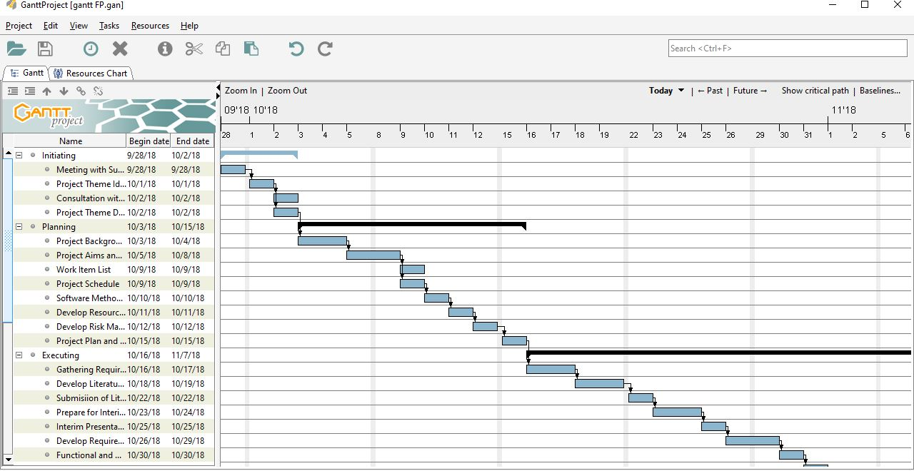

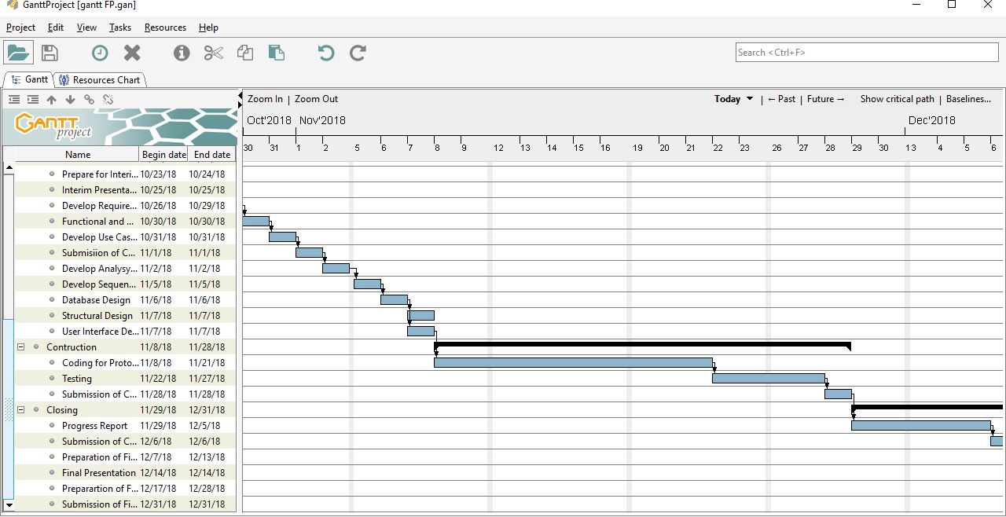
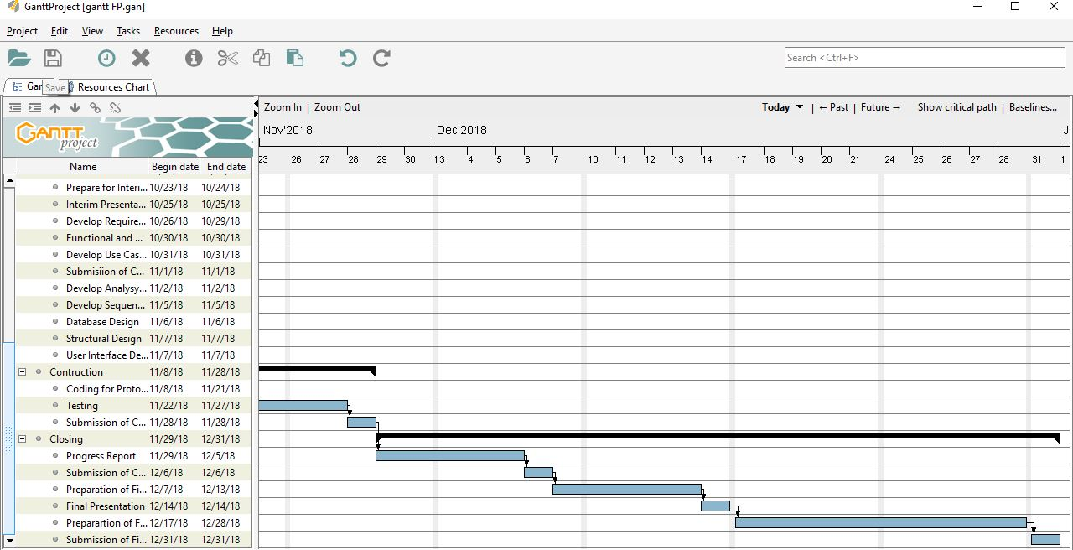

- DURATION
Starting Date: 28th September 2018
Duration/elapsed time: 4 months
End Date: 28th December 2018

- PROJECT RESOURCE REQUIREMENTS AND ESTIMATED COSTS*

No | Item | Usage | Qty. | Cost
Hardware
1 | ASUS laptop A456U series | Project development and testing | 1 | Available
2 | Apple MacBook Pro Retina Mid 2014 | Project development and testing | 1 | Available
3 | ASUS laptop A455LF | Project development and testing | 1 | Available
4 | Canon MP 237 | Document printing | 1 | Available
Operating System
5 | Windows 10 | Project development and testing | - | Available
6 | Mac OSX, Ubuntu 16.04 | Project development and testing | - | Available
7 | Windows 10, Backbox Linux | Project development and testing | - | Available
Others
8 | Flask 1.0.2 | Application development | - | Available
9 | Adobe Photoshop CS6 | User interface design | - | Available
10 | Microsoft Visio Pro 2013 | Drawing UML diagrams | - | Available
11 | GanttProject 2.8.5 | Creating project schedule | - | Available
12 | Microsoft Office Word | Creating project document | - | Available
13 | Microsoft Office Power Point 2016 | Creating presentation document | - | Available

- CONTRACTUAL OBLIGATIONS UNDER THIS PROJECT

Team member:
- Dewa Ayu Dewanti Satya Utami (E1500355)
- I Wayan Denny Harry Caka Pratamayasa (E1500365)
- Ida Bagus Budanthara (E1500366)

        - Participation
As a team, we will:
- Responsible and finished the task
- Help to solve problems and giving solution
- Present in every meeting
- Work together to do the task

        - Problem Solving Skill
As a team, we will:
- Communicate about the project problem and giving an advice
- Giving an opinion if anything is not understood
- Respect each other

        - Communication
As a team, we will:
- Discuss about project goals clearly
- Discuss about project ideas
- Discuss about project problems and giving a solution

        - Code of Conduct
As a team, we will:
- Has a good relation with others to support each other as a teamwork
- Work together to solve all project problems
- Distribute tasks and work items equally
- OWNERSHIP OF INTELLECTUAL PROPERTY RIGHTS

All ownership and intellectual property belongs to HELP University

PROJECT MEMBERS DECLARATION
We hereby acknowledge that the all the information given above is true and correct to the best of our knowledge.

Name : Ida Bagus Budanthara

Signature :

Date :

Name : I Wayan Denny Harry Caka Pratamayasa

Signature :

Date :

Name : Dewa Ayu Dewanti Satya Utami

Signature :

Date :
References

Pujuarto, B., Utami, E., & Sudarmawan. (2013). Evaluasi Keamanan Wireless Local Area Network Menggunakan Metode Penetration Testing. Jurnal Dasi, 14(Kasus : Universitas Muhammadiyah Msgelang), 16–20.
Tomanek, M., & Klima, T. (2015). Penetration Testing in Agile Software Development Projects. International Journal on Cryptography and Information Security (IJCIS), 5, 1–7.

